WEEK 1
MODULE 3 – PL SQL PROGRAMMING

NAME : ANANTH KARTHIK V
SUPERSET ID : 6738185

Exercise 1: Control Structures
Given Scenario 1: The bank wants to apply a discount to loan interest rates for customers above 60 years old.
QUERY:
BEGIN
FOR cus IN (
SELECT CUSTOMERID, DOB
FROM CUSTOMERS
) LOOP
IF MONTHS_BETWEEN(SYSDATE, cus.DOB)/12 > 60 THEN
UPDATE LOANS
SET INTERESTRATE = INTERESTRATE - 1
WHERE CUSTOMERID = cus.CUSTOMERID;
DBMS_OUTPUT.PUT_LINE(
'Discount applied for Customer ID: ' ||
cus.CUSTOMERID
);
END IF;
END LOOP;
COMMIT;
END;
/
OUTPUT:
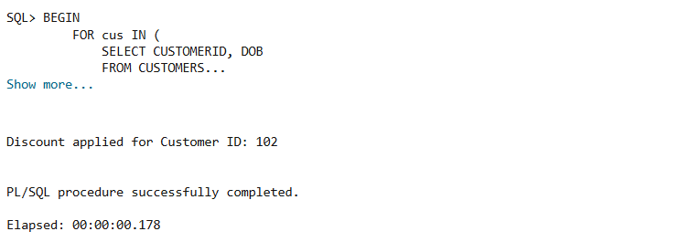

Scenario 2: A customer can be promoted to VIP status based on their balance.
QUERY:
BEGIN
FOR cus IN (
SELECT CUSTOMERID, BALANCE
FROM CUSTOMERS
) LOOP

IF cus.BALANCE > 10000 THEN

UPDATE CUSTOMERS
SET ISVIP = 'TRUE'
WHERE CUSTOMERID = cus.CUSTOMERID;

DBMS_OUTPUT.PUT_LINE(
'VIP Status Granted to Customer ID: ' ||
cus.CUSTOMERID
);

END IF;

END LOOP;

COMMIT;
END;
/

OUTPUT:
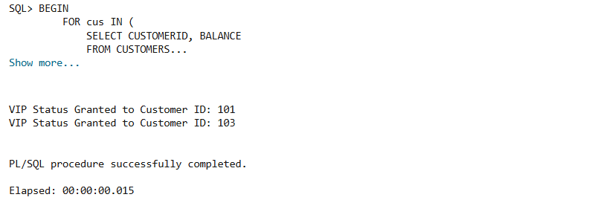

Scenario 3: The bank wants to send reminders to customers whose loans are due within the next 30 days.
QUERY:
BEGIN
FOR loan_rec IN (
SELECT LOANID,
CUSTOMERID,
DUEDATE
FROM LOANS
WHERE DUEDATE BETWEEN SYSDATE
AND SYSDATE + 30
) LOOP

DBMS_OUTPUT.PUT_LINE(
'Reminder: Loan ID ' ||
loan_rec.LOANID ||
' for Customer ID ' ||
loan_rec.CUSTOMERID ||
' is due on ' ||
TO_CHAR(loan_rec.DUEDATE,'DD-MON-YYYY')
);

END LOOP;
END;
/
OUTPUT:
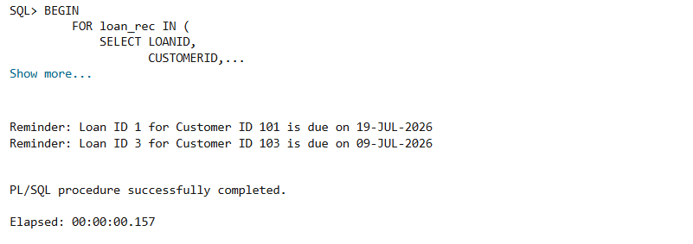

Exercise 2: Error Handling
Given Scenario 1: Handle exceptions during fund transfers between accounts
QUERY:
CREATE OR REPLACE PROCEDURE SafeTransferFunds(
p_from_account NUMBER,
p_to_account NUMBER,
p_amount NUMBER
)
IS
v_balance NUMBER;
BEGIN

-- Get source account balance
SELECT Balance
INTO v_balance
FROM Accounts
WHERE AccountID = p_from_account;

-- Check balance
IF v_balance < p_amount THEN
RAISE_APPLICATION_ERROR(
-20001,
'Insufficient funds in source account'
);
END IF;

-- Debit source account
UPDATE Accounts
SET Balance = Balance - p_amount
WHERE AccountID = p_from_account;

-- Credit destination account
UPDATE Accounts
SET Balance = Balance + p_amount
WHERE AccountID = p_to_account;

COMMIT;

DBMS_OUTPUT.PUT_LINE('Transfer Successful');

EXCEPTION
WHEN OTHERS THEN
ROLLBACK;
DBMS_OUTPUT.PUT_LINE(
'Transfer Failed: ' || SQLERRM
);
END;
/
Output:

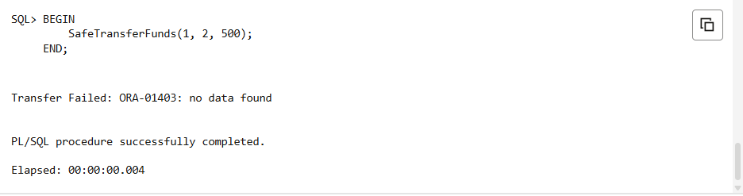

Scenario 2: Manage errors when updating employee salaries.
QUERY:
CREATE OR REPLACE PROCEDURE UpdateSalary(
p_empid NUMBER,
p_percentage NUMBER
)
IS
BEGIN

UPDATE Employees
SET Salary = Salary + (Salary * p_percentage / 100)
WHERE EmployeeID = p_empid;

IF SQL%ROWCOUNT = 0 THEN
RAISE NO_DATA_FOUND;
END IF;

COMMIT;

DBMS_OUTPUT.PUT_LINE(
'Salary Updated Successfully'
);

EXCEPTION
WHEN NO_DATA_FOUND THEN
DBMS_OUTPUT.PUT_LINE(
'Error: Employee ID does not exist'
);

WHEN OTHERS THEN
DBMS_OUTPUT.PUT_LINE(
'Error: ' || SQLERRM
);
END;
/
OUTPUT:
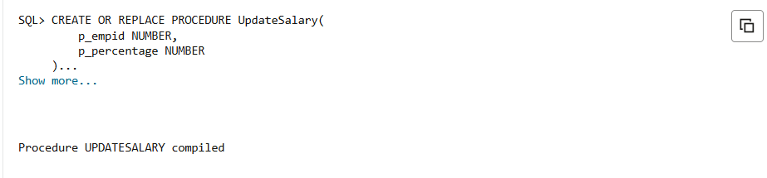
Scenario 3: Ensure data integrity when adding a new customer.
QUERY:
CREATE OR REPLACE PROCEDURE AddNewCustomer(
p_customerid NUMBER,
p_name VARCHAR2,
p_dob DATE,
p_balance NUMBER
)
IS
BEGIN

INSERT INTO Customers(
CustomerID,
Name,
DOB,
Balance,
LastModified
)
VALUES(
p_customerid,
p_name,
p_dob,
p_balance,
SYSDATE
);

COMMIT;

DBMS_OUTPUT.PUT_LINE(
'Customer Added Successfully'
);

EXCEPTION
WHEN DUP_VAL_ON_INDEX THEN
DBMS_OUTPUT.PUT_LINE(
'Error: Customer ID already exists'
);

WHEN OTHERS THEN
DBMS_OUTPUT.PUT_LINE(
'Error: ' || SQLERRM
);
END;
/

OUTPUT:
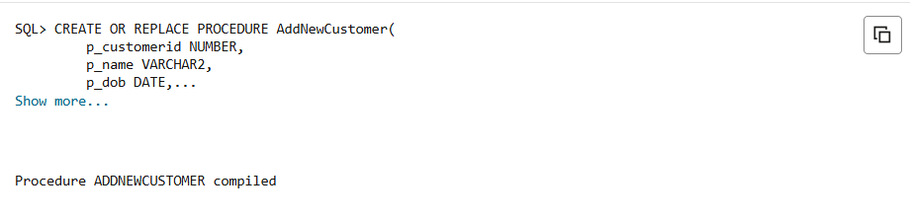

Exercise 3: Stored Procedures
Scenario 1: The bank needs to process monthly interest for all savings accounts.
QUERY:
CREATE OR REPLACE PROCEDURE ProcessMonthlyInterest
AS
BEGIN
UPDATE ACCOUNTS
SET BALANCE = BALANCE + (BALANCE * 0.01)
WHERE ACCOUNTTYPE = 'SAVINGS';

COMMIT;

DBMS_OUTPUT.PUT_LINE('Monthly interest processed successfully.');
END;
/
OUTPUT:
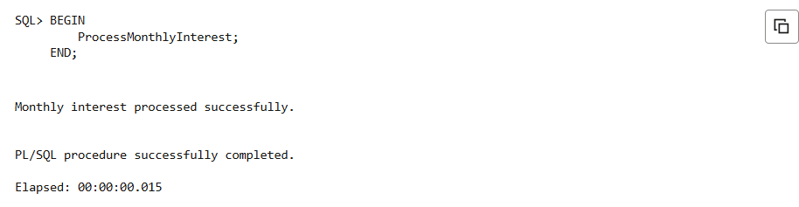

Scenario 2: The bank wants to implement a bonus scheme for employees based on their performance.
QUERY:
CREATE OR REPLACE PROCEDURE UpdateEmployeeBonus(
p_department IN VARCHAR2,
p_bonus_percent IN NUMBER
)
AS
BEGIN
UPDATE EMPLOYEES
SET SALARY = SALARY +
(SALARY * p_bonus_percent / 100)
WHERE DEPARTMENT = p_department;

COMMIT;

DBMS_OUTPUT.PUT_LINE(
'Bonus updated for department: ' ||
p_department
);
END;
/
OUTPUT:
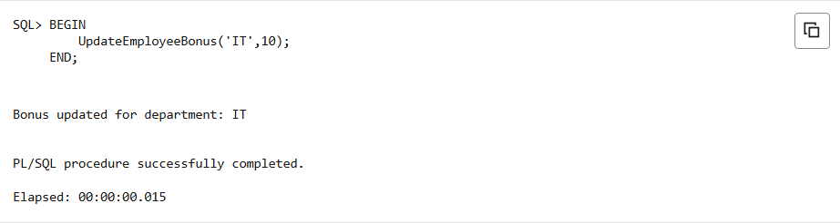

Scenario 3: Customers should be able to transfer funds between their accounts.
QUERY:
CREATE OR REPLACE PROCEDURE TransferFunds(
p_from_account IN NUMBER,
p_to_account IN NUMBER,
p_amount IN NUMBER
)
AS
v_balance NUMBER;
BEGIN

SELECT BALANCE
INTO v_balance
FROM ACCOUNTS
WHERE ACCOUNTID = p_from_account;

IF v_balance >= p_amount THEN

UPDATE ACCOUNTS
SET BALANCE = BALANCE - p_amount
WHERE ACCOUNTID = p_from_account;

UPDATE ACCOUNTS
SET BALANCE = BALANCE + p_amount
WHERE ACCOUNTID = p_to_account;

COMMIT;

DBMS_OUTPUT.PUT_LINE(
'Transfer Successful'
);

ELSE

DBMS_OUTPUT.PUT_LINE(
'Insufficient Balance'
);

END IF;

EXCEPTION
WHEN NO_DATA_FOUND THEN
DBMS_OUTPUT.PUT_LINE(
'Account Not Found'
);
END;
/

OUTPUT:
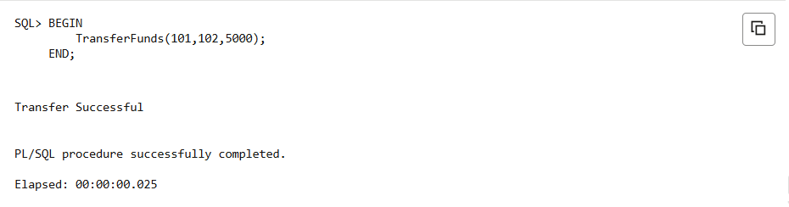

Exercise 4: Functions
Scenario 1: Calculate the age of customers for eligibility checks
QUERY:
CREATE OR REPLACE FUNCTION CalculateAge(
p_dob DATE
)
RETURN NUMBER
IS
BEGIN
RETURN TRUNC(
MONTHS_BETWEEN(SYSDATE, p_dob) / 12
);
END;
/
Output:
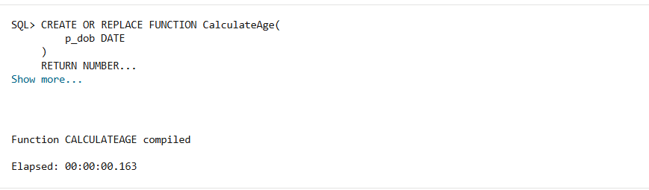

Scenario 2: The bank needs to compute the monthly installment for a loan.
QUERY:
CREATE OR REPLACE FUNCTION CalculateMonthlyInstallment(
p_loan_amount NUMBER,
p_interest_rate NUMBER,
p_years NUMBER
)
RETURN NUMBER
IS
v_months NUMBER;
v_total_amount NUMBER;
BEGIN

v_months := p_years * 12;

v_total_amount :=
p_loan_amount +
(p_loan_amount * p_interest_rate/100 * p_years);

RETURN ROUND(
v_total_amount / v_months,
2
);

END;
/

Output:
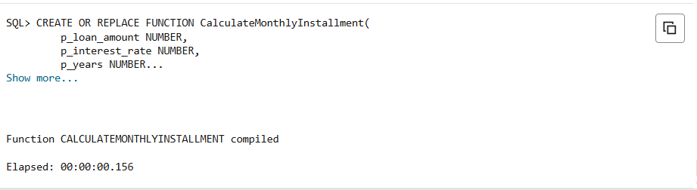

Scenario 3: Check if a customer has sufficient balance before making a transaction
QUERY:
SET SERVEROUTPUT ON;

DECLARE
v_result BOOLEAN;
BEGIN

v_result := HasSufficientBalance(
1,
500
);

IF v_result THEN
DBMS_OUTPUT.PUT_LINE(
'Sufficient Balance'
);
ELSE
DBMS_OUTPUT.PUT_LINE(
'Insufficient Balance'
);
END IF;

END;
/

Output:
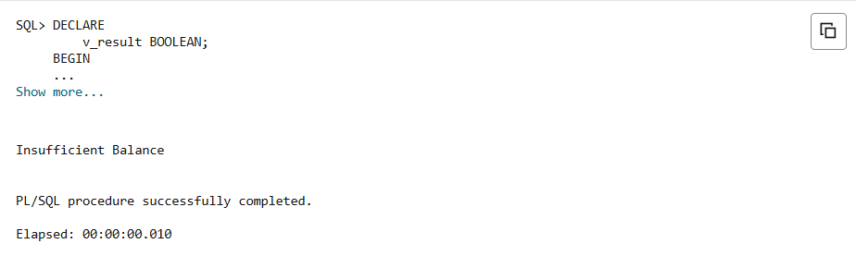
Exercise 5: Triggers
Given Scenario 1: Automatically update the last modified date when a customer's record is updated.
QUERY:
CREATE OR REPLACE TRIGGER UpdateCustomerLastModified
BEFORE UPDATE ON Customers
FOR EACH ROW
BEGIN
:NEW.LastModified := SYSDATE;
END;
/

Output:
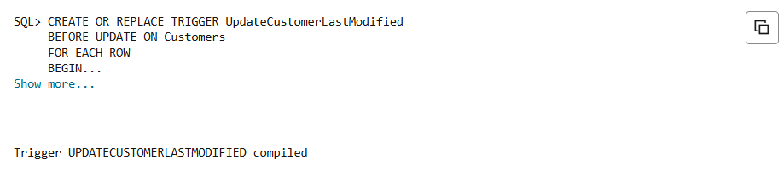

Scenario 2: Maintain an audit log for all transactions.
QUERY:
CREATE OR REPLACE TRIGGER LogTransaction
AFTER INSERT ON Transactions
FOR EACH ROW
BEGIN

INSERT INTO AuditLog(
TransactionID,
LogDate,
Description
)
VALUES(
:NEW.TransactionID,
SYSDATE,
'Transaction Added'
);

END;
/

Output:
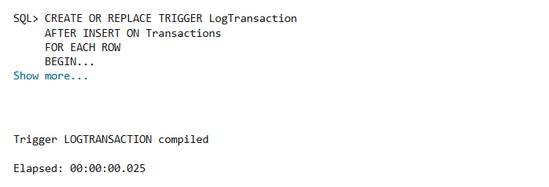

Scenario 3: Enforce business rules on deposits and withdrawals.
QUERY:
CREATE OR REPLACE TRIGGER CheckTransactionRules
BEFORE INSERT ON Transactions
FOR EACH ROW
DECLARE
v_balance NUMBER;
BEGIN

SELECT Balance
INTO v_balance
FROM Accounts
WHERE AccountID = :NEW.AccountID;

IF :NEW.TransactionType = 'Withdrawal'
AND :NEW.Amount > v_balance THEN

RAISE_APPLICATION_ERROR(
-20001,
'Withdrawal exceeds available balance'
);

END IF;

IF :NEW.TransactionType = 'Deposit'
AND :NEW.Amount <= 0 THEN

RAISE_APPLICATION_ERROR(
-20002,
'Deposit amount must be positive'
);

END IF;

END;
/

Output:
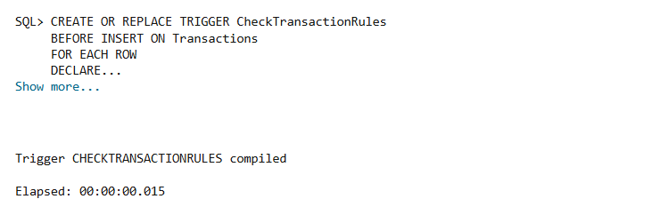

Exercise 6: Cursors:
Scenario 1: Generate monthly statements for all customers.
QUERY:
DECLARE
CURSOR c_monthly_txns IS
SELECT t.TransactionID,t.AccountID,t.TransactionDate,t.Amount,t.TransactionType,a.CustomerID
FROM Transactions t
JOIN Accounts a ON t.AccountID = a.AccountID
WHERE TRUNC(t.TransactionDate, 'MM') = TRUNC(SYSDATE, 'MM');
BEGIN
FOR rec IN c_monthly_txns LOOP
DBMS_OUTPUT.PUT_LINE(
'CustomerID: ' || rec.CustomerID ||
', AccountID: ' || rec.AccountID ||
', TransactionID: ' || rec.TransactionID ||
', Date: ' || TO_CHAR(rec.TransactionDate, 'DD-MON-YYYY') ||
', Type: ' || rec.TransactionType ||
', Amount: ' || rec.Amount
);
END LOOP;
END;
/
Output:
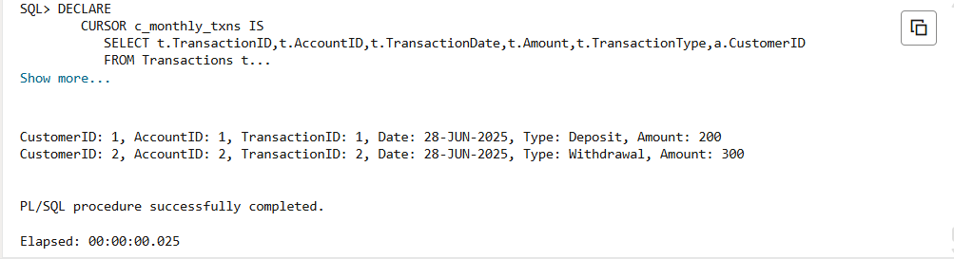

Scenario 2: Apply annual fee to all accounts.
QUERY:
DECLARE
CURSOR c_accounts IS
SELECT AccountID, Balance
FROM Accounts;
BEGIN
FOR rec IN c_accounts LOOP
UPDATE Accounts
SET Balance = Balance - 50
WHERE AccountID = rec.AccountID;
DBMS_OUTPUT.PUT_LINE('Annual fee deducted from AccountID: ' || rec.AccountID ||'. New Balance: ' || (rec.Balance - 50));
END LOOP;
COMMIT;
END;
/

Output:
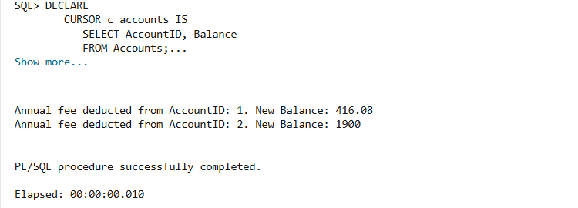

Scenario 3: Update the interest rate for all loans based on a new policy.
QUERY:
DECLARE
CURSOR c_loans IS
SELECT LoanID, InterestRate
FROM Loans;
v_new_rate NUMBER;
BEGIN
FOR rec IN c_loans LOOP
IF rec.InterestRate < 5 THEN
v_new_rate := rec.InterestRate + 1;
ELSE
v_new_rate := rec.InterestRate - 0.5;
END IF;
UPDATE Loans
SET InterestRate = v_new_rate
WHERE LoanID = rec.LoanID;
DBMS_OUTPUT.PUT_LINE('LoanID: ' || rec.LoanID || ', Old Rate: ' || rec.InterestRate || ', New Rate: ' || v_new_rate );
END LOOP;
COMMIT;
END;
/
Output:
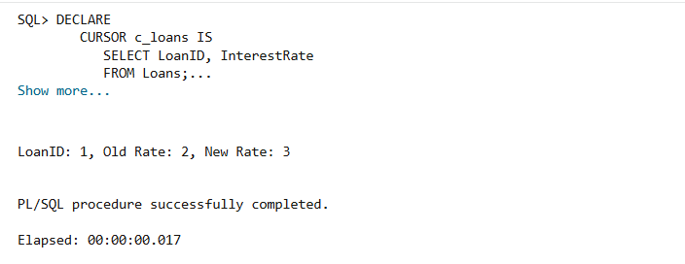

Exercise 7: Packages:
Scenario 1: Group all customer-related procedures and functions into a package
QUERY:
CREATE OR REPLACE PACKAGE CustomerManagement IS
PROCEDURE AddCustomer(p_customer_id NUMBER, p_name VARCHAR2,p_dob DATE, p_balance NUMBER);
PROCEDURE UpdateCustomer(p_customer_id NUMBER, p_name VARCHAR2,p_balance NUMBER );
FUNCTION GetBalance(p_customer_id NUMBER ) RETURN NUMBER;
END CustomerManagement;
/
BEGIN
CustomerManagement.AddCustomer(10, 'New Customer', TO_DATE('1973-11-21','YYYY-MM-DD'), 2000);
CustomerManagement.UpdateCustomer(10, 'Updated Name', 3000);
DBMS_OUTPUT.PUT_LINE('Balance: ' || CustomerManagement.GetBalance(10));
END;
/
Output:
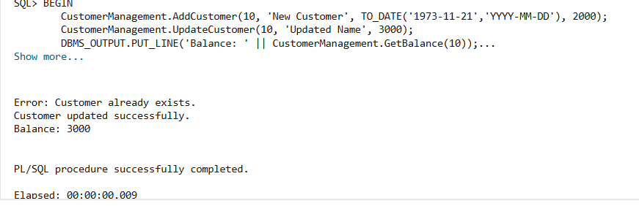

Scenario 2: Create a package to manage employee data.
QUERY:
CREATE OR REPLACE PACKAGE EmployeeManagement IS
PROCEDURE HireEmployee(p_employee_id NUMBER,p_name VARCHAR2,p_position VARCHAR2,p_salary NUMBER,p_department VARCHAR2,p_hiredate DATE);
PROCEDURE UpdateEmployee(p_employee_id NUMBER,p_salary NUMBER,p_department VARCHAR2);
FUNCTION AnnualSalary(
p_employee_id NUMBER
) RETURN NUMBER;
END EmployeeManagement;
/
CREATE OR REPLACE PACKAGE BODY EmployeeManagement IS
PROCEDURE HireEmployee(
p_employee_id NUMBER,
p_name VARCHAR2,
p_position VARCHAR2,
p_salary NUMBER,
p_department VARCHAR2,
p_hiredate DATE
) IS
BEGIN
INSERT INTO Employees (
EmployeeID, Name, Position, Salary, Department, HireDate
)
VALUES (
p_employee_id, p_name, p_position, p_salary, p_department, p_hiredate
);
COMMIT;
DBMS_OUTPUT.PUT_LINE('Employee hired successfully.');
EXCEPTION
WHEN DUP_VAL_ON_INDEX THEN
DBMS_OUTPUT.PUT_LINE('Error: Employee already exists.');
END HireEmployee;

PROCEDURE UpdateEmployee(
p_employee_id NUMBER,
p_salary NUMBER,
p_department VARCHAR2
) IS
BEGIN
UPDATE Employees
SET Salary = p_salary,
Department = p_department
WHERE EmployeeID = p_employee_id;

IF SQL%ROWCOUNT = 0 THEN
DBMS_OUTPUT.PUT_LINE('Employee not found.');
ELSE
DBMS_OUTPUT.PUT_LINE('Employee updated successfully.');
END IF;

COMMIT;
END UpdateEmployee;
FUNCTION AnnualSalary(
p_employee_id NUMBER
) RETURN NUMBER IS
v_salary NUMBER;
BEGIN
SELECT Salary INTO v_salary
FROM Employees
WHERE EmployeeID = p_employee_id;

RETURN v_salary * 12;
EXCEPTION
WHEN NO_DATA_FOUND THEN
RETURN NULL;
END AnnualSalary;
END EmployeeManagement;
/
BEGIN
EmployeeManagement.HireEmployee(10, 'Sam Smith', 'Analyst', 5000, 'Finance', SYSDATE);
EmployeeManagement.UpdateEmployee(10, 6000, 'Finance');
DBMS_OUTPUT.PUT_LINE('Annual Salary: ' || EmployeeManagement.AnnualSalary(10));
END;
/

Output:
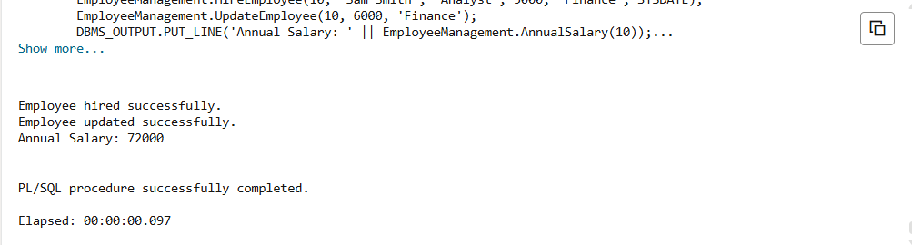

Scenario 3: Group all account-related operations into a package.
QUERY:
CREATE OR REPLACE PACKAGE BODY AccountOperations IS
PROCEDURE OpenAccount(
p_account_id NUMBER,
p_customer_id NUMBER,
p_type VARCHAR2,
p_balance NUMBER
) IS
BEGIN
INSERT INTO Accounts (
AccountID, CustomerID, AccountType, Balance, LastModified
)
VALUES (
p_account_id, p_customer_id, p_type, p_balance, SYSDATE
);
COMMIT;
DBMS_OUTPUT.PUT_LINE('Account opened successfully.');
EXCEPTION
WHEN DUP_VAL_ON_INDEX THEN
DBMS_OUTPUT.PUT_LINE('Error: Account already exists.');
END OpenAccount;
PROCEDURE CloseAccount(
p_account_id NUMBER
) IS
BEGIN
DELETE FROM Accounts
WHERE AccountID = p_account_id;
IF SQL%ROWCOUNT = 0 THEN
DBMS_OUTPUT.PUT_LINE('Account not found.');
ELSE
DBMS_OUTPUT.PUT_LINE('Account closed successfully.');
END IF;
COMMIT;
END CloseAccount;
FUNCTION GetTotalBalance(
p_customer_id NUMBER
) RETURN NUMBER IS
v_total NUMBER;
BEGIN
SELECT SUM(Balance)
INTO v_total
FROM Accounts
WHERE CustomerID = p_customer_id;
RETURN NVL(v_total,0);
END GetTotalBalance;
END AccountOperations;
/
BEGIN
AccountOperations.OpenAccount(20, 1, 'Savings', 1000);
AccountOperations.CloseAccount(20);
DBMS_OUTPUT.PUT_LINE('Total Balance: ' || AccountOperations.GetTotalBalance(1));
END;
/

Output:
